**Smart Excavator Based on ADI Technology**

**Individual Report – 3/7/2016**

Benjamin Withers – Imperial College London

**Preface**

This report covers the initial observations and ideas made by Benjamin Withers, a second year Electronic and Information Engineering student at Imperial College London. The project in question is a research project currently being undertaken by four Tsinghua University students. I have joined this team for a term of 2 months as part of Imperial’s IROP scheme with Tsinghua. The timeframe extends beyond that, but I hope to assist the team and make an impact on the final outcome of the project. More details can be found in the team’s existing PowerPoint presentation. (Can be provided with permission)

**Project Introduction**

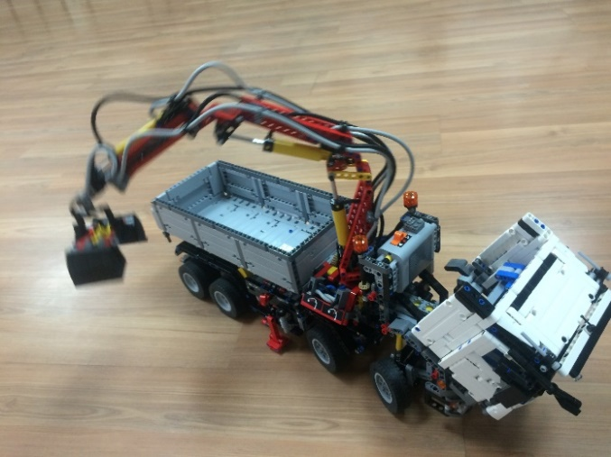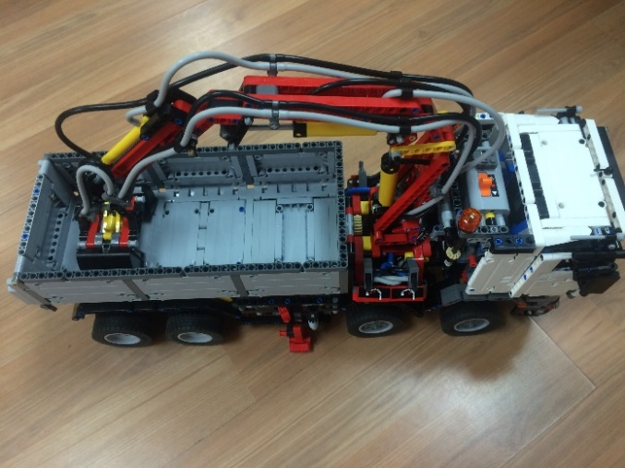The project is titled “Smart Excavator Based on ADI Technology” and is quite self-explanatory. The idea is to revolutionise the construction market by developing an unmanned excavator, which will not only improve efficiency by removing human error, but also improve safety aspects. The type of excavator must be clarified; currently it is a type of truck with a large skip on the back with an excavator arm mounted behind the cab. This LEGO™ excavator (shown in Figures 1 and 2) is the one the team plans to automate.

Figure 1 - Arm extended

Figure 2 - Excavator

ADI Technology refers to the products made by the ADI company ([www.analog.com](http://www.analog.com)). The products mentioned in the team’s project PowerPoint presentation (which contains team member descriptions and project specifics, such as proposed ADI products, etc.) are geared towards the sensing side of the system. This encompasses object detection and tracking, which will be used for vehicle guidance, object avoidance (can be referred to collision avoidance with regard to other vehicles, stationary objects and of course humans) and target object detection. I am sure there may be more concepts involved in the system.

**System Overview**

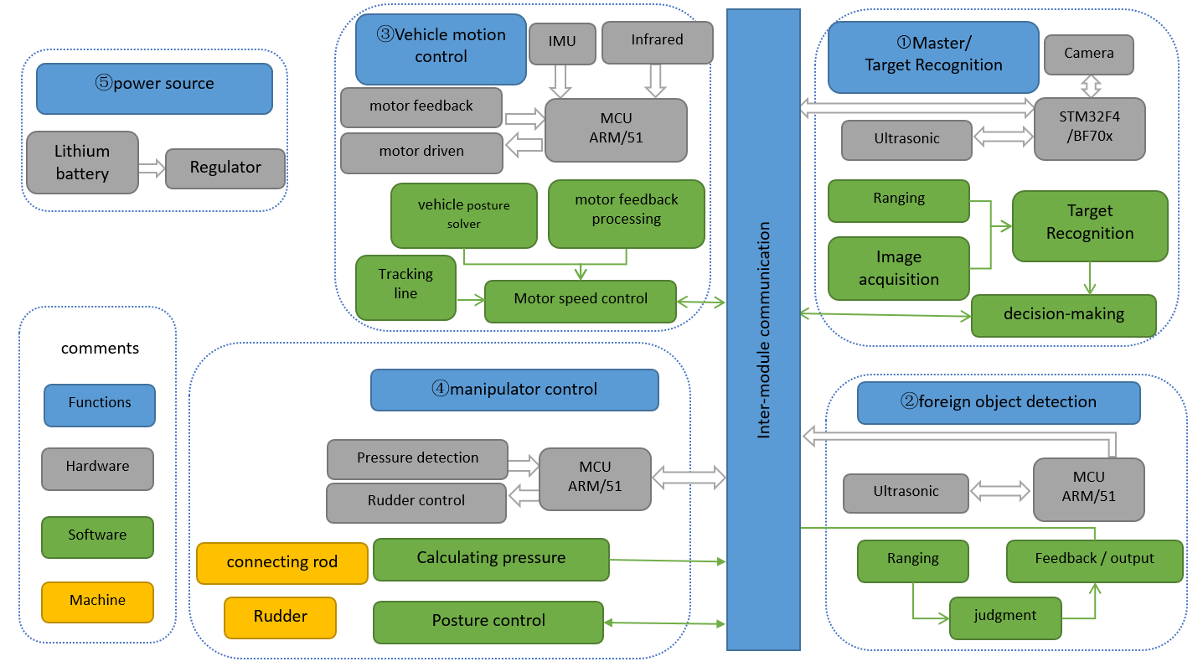Speaking of the system, the team has already made a System Architecture Overview Diagram (AOD). On a personal note, I am sure the IT architects at IBM would be happy with it, even if it is not up to their standards. It was nice to see, considering that it was only a couple of weeks ago that EIE2 finished their week-long IBM workshop.

Figure 3 - System AOD

As the diagram implies, the team has split the problem into several modules that they plan to tackle, along with some way to interconnect them. 5 modules are shown and out of them, number 5 – power source, will be the easiest to do once the rest is done. The others will take a while to complete. Again it is good to see that the two types of object detection have been separated into **Target Recognition** and **Foreign Object Detection**. These definitely are two parts of the system and must be dealt with separately. Collision avoidance is a part of module 2 and control of the manipulator in module 4 will also be governed by module 1. Some of the ADI products have been mentioned here too, shown in the grey hardware colour.

**Deadlines**

Following that, the team has specified a set of deadlines. This has been split into 3 stages, all of which have realistic goals in mind. They are listed below.

* **Stage I**
  + Excavator goes to the target area by using infrared tracking
  + Function modules: motor driver, tracking, truck bed control
  + Schedule: 7/15
* **Stage II**
  + Add camera, ultrasonic sensors, magnetic angle sensor & gyro
  + Function modules: ranging, motor control, obstacle avoidance
  + Schedule: 8/25
* **Stage III**
  + Modify the structure of the manipulator, realize manipulator control & automatic digging
  + Function modules: target detection & recognition, manipulator control
  + Schedule: 10/1

I will be present for Stages I and II, but hopefully I can help set the groundwork up for Stage III. Personally, I think this project is very interesting and ties in very nicely with my course and areas I am interested in. Being a committee member of the Imperial College Robotics Society will also help in terms of experience and motivation, as this research project work falls right into what we do at ICRS.

**Observations and Issues**

To start off, I admit I am completely unfamiliar with ADI and their products. I will try to learn how to use some of the components once they arrive if need be, but hopefully I can leave that to one of the other members. I think they had good reason for choosing the products they highlighted in their presentation and I cannot argue otherwise.

The supervising professor noticed that the LEGO™ excavator truck was way too fragile for the project, which I immediately agreed with. The construction of that toy was never intended to carry electronics and serve as a platform which we could build onto. Therefore it was decided on the spot that we would have to find a replacement vehicle. I have some ideas on the matter that I will share in the next section.

Next was the control system, aka the brains of the vehicle. The supervisor was trying to think of a way in which we could control the vehicle, such as an FPGA or some other microcontroller. Luckily I had a great idea that immediately came to mind and was accepted by the supervisor and members present.

OpenCV is an open-source project for computer vision, which we may eventually use for object detection and so on in tandem with the ADI sensors. It is mainly written in C++, which is a big plus, no pun intended, since most of us are well-versed in C++. My only concern is working with the Pi, as most standard libraries (for the GPIO, HATs and so on) are written in Python. Some research led to finding a workaround, which I will discuss later.

There are many other issues that may come up, but at the moment, we are mainly concerned with the basics. With regard to the modules described in the AOD, any specific problems or issues will be addressed later on.

**Ideas**

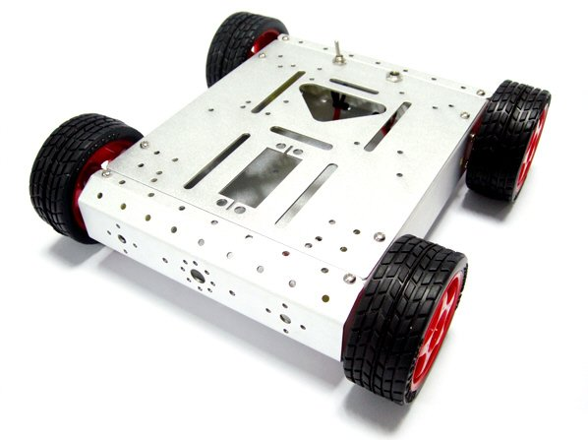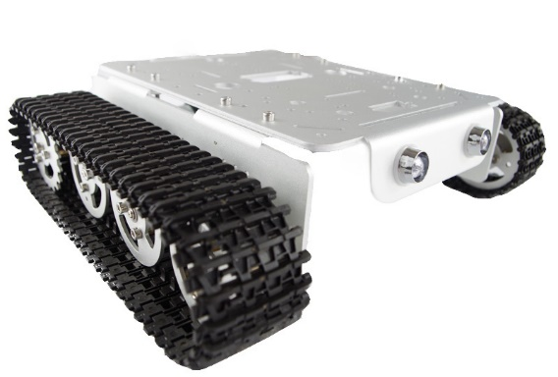The vehicle must be able to carry a skip (a box to hold objects), a manipulator arm (similar to an excavator arm) and all the electronics involved. It must also be able to traverse somewhat rough terrain. Therefore it must be robust, have some all-terrain qualities and must be expandable. A vehicle with a platform for us to attach components and build onto would be ideal. A solution I propose is to purchase a robot base, the kind that has 4 wheels, each with motors, and a metal chassis that has mounting holes for Arduinos/Pis and other sensors. This kind of robotics platform is readily available in various forms in the USA and UK. A version is available on Taobao, although I am not certain whether the size is sufficient. Sadly Taobao has a very limited range of options, so we may have to make do or find something else. The Figures below depict different robot bases available outside China.

Figure 4 - Tank Robot Base

Figure 5 - 4 Wheel Drive Robot Base

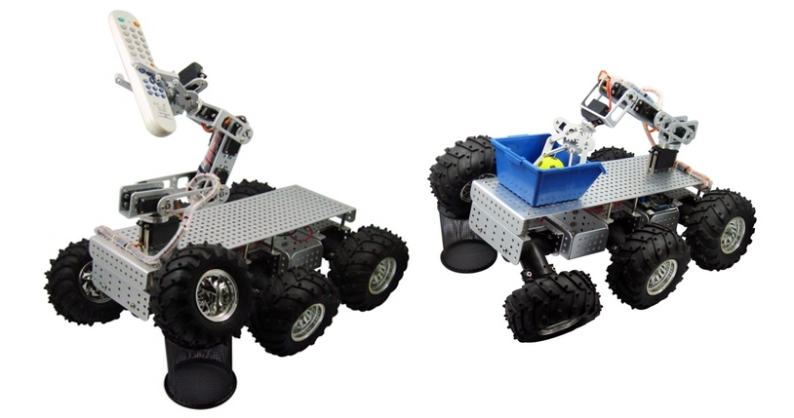

Figure 6 - 6 Wheel Drive Robot Base with Manipulator Arm

Figure 4 – Source: http://g01.a.alicdn.com/kf/HTB1sPulJXXXXXX0XpXXq6xXFXXXT/T200-Aluminum-Alloy-Metal-font-b-Tank-b-font-Track-Cater-pillar-font-b-Chassis-b.jpg

Figure 5 – Source: http://i01.i.aliimg.com/img/pb/605/403/364/364403605_958.jpg

Figure 6 – Source: http://www.dagurobot.com/goods.php?id=47

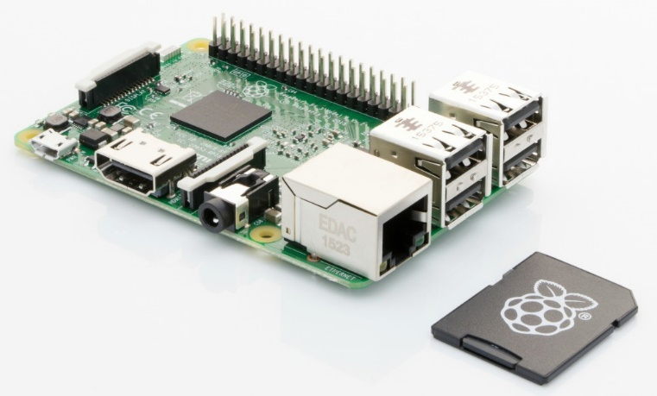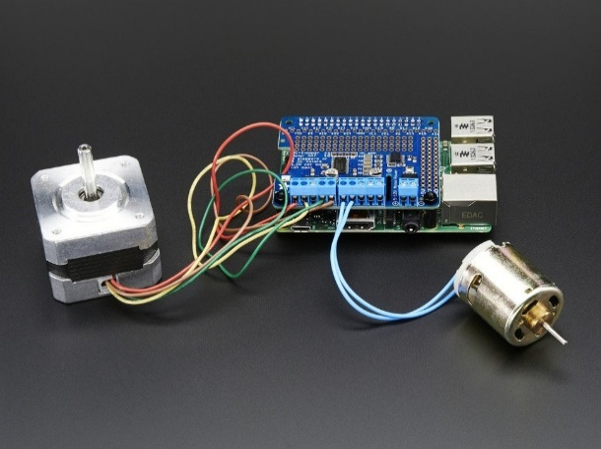As for the control centre of the vehicle, I suggested a Raspberry Pi™, an incredibly small computer, which has been increasing in popularity over the past few years in the hacker and maker communities. It has several GPIO pins which can be used to control many things, ranging from LEDs to ultrasonic sensors. With an expansion board, known as a HAT (similar to an Arduino SHIELD), the Pi can control various types of motors, and interface with sensors, all with different HATs, which are in fact stackable. The supervisor thought this was amazing (as she had never heard of such a cheap small LINUX computer) and luckily one of the team members not only had heard of them, but owned 2 Pis (an original Pi B+ and a Pi 2). The supervisor suggested we get one each of the latest revision (the Pi 3 in fact), which was great news to us. This was my first major contribution to the project and quite an important one too, since we will be able to work in C++ (or Python) on LINUX and eventually with OpenCV.

Figure 7 – Raspberry Pi 3

Figure 8 – Stepper and DC Motor HAT

While doing some research on Raspberry Pi GPIO, I found a website (wiringpi.com) which contains a GPIO interface library for the Pi. Additionally, this library is written in C in the style of the Arduino “wiring convention”. In essence, anyone familiar with Arduinos and C/C++ will find this library incredibly useful. With that matter out of the way, I will have to investigate how to use HATs and research which HATs are available in China and which are compatible with our other hardware (motors and sensors).

**Plan**

This section will cover what I plan to do for the next week. Once hardware starts arriving, the project will progress faster, as testing will be easier.

By the end of the week (10th July), I will research the types of HATs available in China and decide/advise on which ones will work and benefit the project. The faster I do this, the sooner we will have a physical copy to work with. Depending on the language barrier (although not a big issue) and online retailers, I may be able to do this within 2 days.

Figure 7 – Source: https://www.pi-supply.com/wp-content/uploads/2016/02/pi_angled_noobs- new.jpg

Figure 8 – Source: https://cdn.shopify.com/s/files/1/0176/3274/products/2348-01_1024x1024.jpeg?v=1456170305

If the team has not decided on a base vehicle, I will take a look into the options available. They can easily be modified (using 3D printers, which the team does not seem to have access to, an issue I can probably solve) and I will most likely take 2 days to decide on an appropriate base vehicle with decent specs. Figure 6 shows a robot base with additional servo motor based manipulator arm, which looks remarkably like the vehicle I believe the team needs. Turns out this is also available on Taobao, we just need to know what size and what other specs we require of it. In addition, I will look into manipulator arms. There are many hobbyist robotic arms out there, but we require one that has at least 4 degrees of freedom (most I see on Taobao that meet our specs are 6 degreed of freedom) and can lift some mass (sand, weighted balls, etc.).

I already have looked a bit into OpenCV, but since my knowledge on image processing is limited, I’ll focus my efforts elsewhere, but using OpenCV is not too hard, just a matter of learning the parts applicable to the project, which I must confirm with the team member working on this (Wang Shuo).

Once the Raspberry Pi 3s arrive, I can really get into figuring out the GPIO and then start working with the GPIO library stated above. I must talk with Weng Zhe about work regarding the Pis, as he is the hardware expert on the team.

Of course, I will take care in confirming my plans and work with the other team members to ensure nothing counter-productive is done and that time is used efficiently.

**Conclusion**

Now with a plan in mind, I can set out to accomplish my set goals and help out the other team members. I will be sticking to the software and hardware side of things, but with my previous hobbyist robot experience (from ICRS), I can help out with the construction and modification of the robot chassis and arm.

**Notes**

This concludes the first Individual Report, the next will be written in a week’s time. Each report will contain information about what was accomplished that week and what is planned for the next week. Only research project information will be covered in these reports. The final report will come in two parts, the final project report summarising everything I did at Tsinghua and a report on what I did in my free time, such as visiting landmarks and other cities (for the International Relations Office at Imperial).